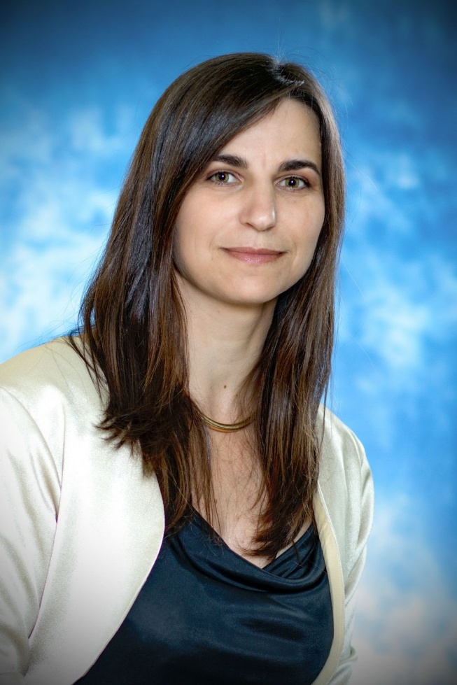 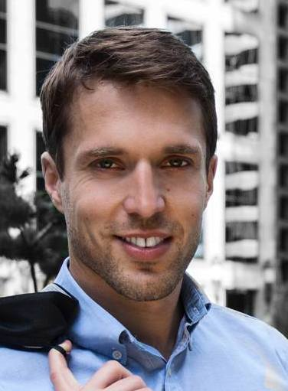 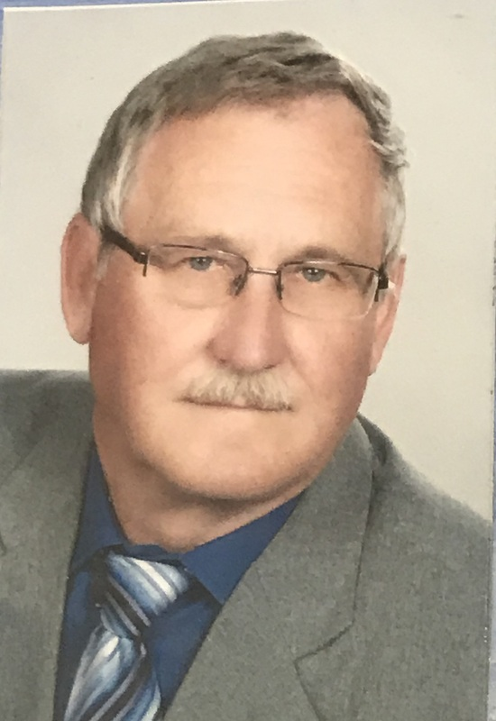

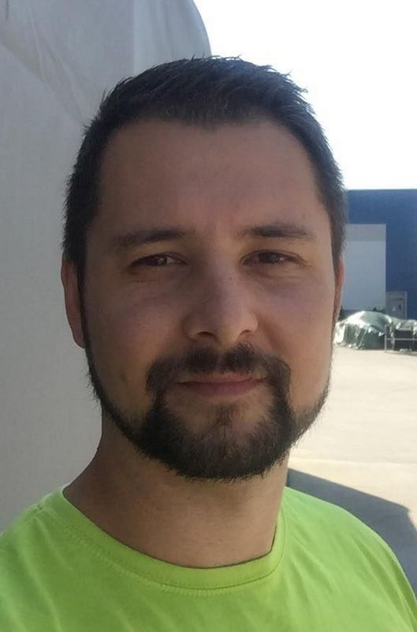 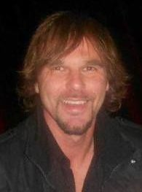 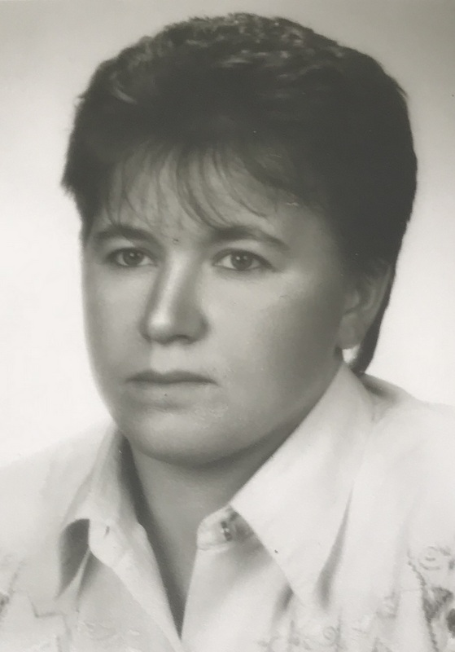

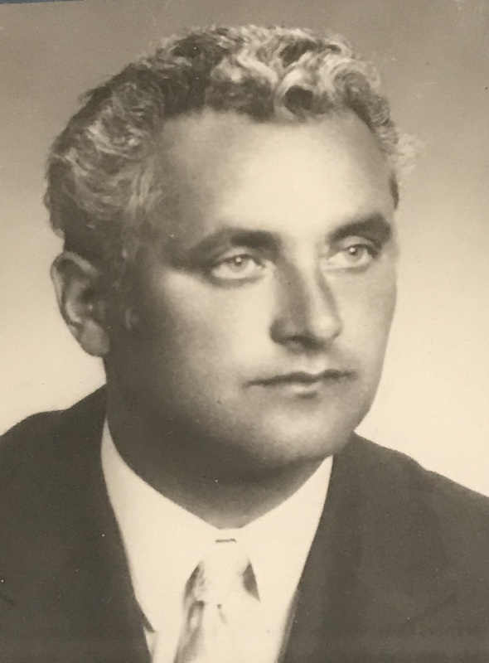 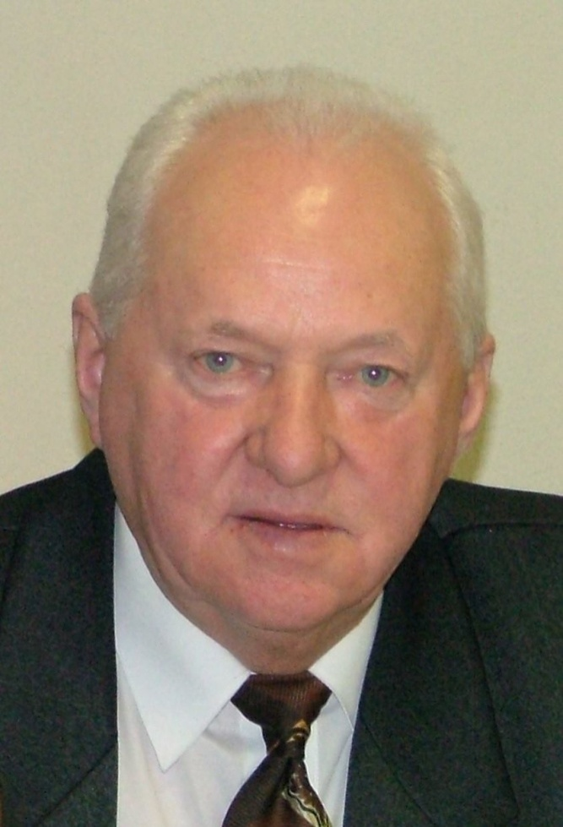

|  |  |
| --- | --- |
| Mgr. František Arendáš  (1980 – 2017) | Mgr. Jozef Lacko  (2002 – 2009) |
| Mgr. Ľubomír Virčík  (2009 – 2013) | Mgr. Daniel Loja  (2006 – 2007) |
| Mgr. Anna Adamová  (1989 – 1997) | Jozef Školník  (1954 – 1989) |
| Mgr. Katarína Vozárová  (2002 – 2009) (2013 – 2019) | Milan Timkovič  (1997 – 2002) |
| Mgr. Richard Andraško  (2019 – 2009) |  |